**20 C# Programs Assignment**

**By**

**B .P.N.V.S.Sudheer**

**27-01-2022**

**1 . WACP Program Print Multiplication Table Of a given number**

**using System;**

**using System.Collections.Generic;**

**using System.Linq;**

**using System.Text;**

**using System.Threading.Tasks;**

**namespace multiplication_of_a_number**

**{**

**internal class Program**

**{**

**static void Main(string[] args)**

**{**

**int input, i;**

**Console.WriteLine("enter a number");**

**input = Convert.ToInt32(Console.ReadLine());**

**for ( i = 1; i <= 10; i++)**

**{**

**Console.Write(input+"x"+i+"="+input*i);**

**}**

**Console.ReadLine();**

**}**

**}**

**}**

**Output:**

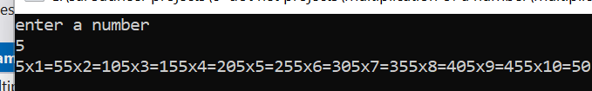

**2. WACP To Print Factorial of a given number**

**using System;**

**using System.Collections.Generic;**

**using System.Linq;**

**using System.Text;**

**using System.Threading.Tasks;**

**namespace factorial_number**

**{**

**internal class Program**

**{**

**static void Main(string[] args)**

**{**

**int i, n, fact = 1;**

**Console.WriteLine("Enter any number:");**

**n = Convert.ToInt32(Console.ReadLine());**

**for (i = 1; i <= n; i++)**

**{**

**fact = fact * i;**

**Console.WriteLine("fact="+fact);**

**}**

**Console.ReadLine();**

**}**

**}**

**}**

**Output :**

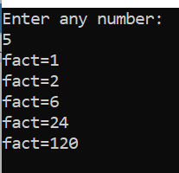

3. WACP To Print Sum of N Natural Numbers

using System;

using System.Collections.Generic;

using System.Linq;

using System.Text;

using System.Threading.Tasks;

namespace natural_number

{

internal class Program

{

static void Main(string[] args)

{

int i, n, sum = 0;

Console.WriteLine(" Enter any numbers:");

n = Convert.ToInt32(Console.ReadLine());

for (i = 1; i <= n; i++)

sum = sum + i;

Console.WriteLine("sum="+sum);

Console.ReadLine();

}

}

}

Output :

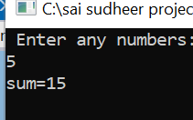

4. WACP To Print Factorial Number using Function

using System;

using System.Collections.Generic;

using System.Linq;

using System.Text;

using System.Threading.Tasks;

namespace codes

{

internal class Program

{

public static void printoutput(int n)

{

Console.WriteLine("factorial of {0} = {1}", n, factorial(n));

}

public static int factorial(int n)

{

int fact = 1;

for (int i = 1; i <= n; i++)

fact = fact * i;

return fact;

}

static void Main(string[] args)

{

int n = 5, n1 = 4, n2 = 6;

printoutput(n);

printoutput(n1);

printoutput(n2);

Console.ReadLine();

}

}

}

Output :

